**RIPHAH INTERNATIONAL UNIVERSITY, ISLAMABAD**



**Lab 6**

Bachelors of Computer Science – 5th semester

**Subject:** Operating System Lab

**Submitted to:** Ma'am Kausar Nasreen Khattak

**Submitted by:** Areeba Sadaqat

Sap Id: 47633

**Date:** 30th September, 2024

**Lab Task**

**Q1**: Explain the process of compiling a C program in Linux. What command is used to compile the program?

**Solution**:  
To compile a C program in Linux using an online terminal, do the following:

* Start by writing code in a file with a .c extension.
* You use a compiler to compile the program. The most common compiler for C programs in Linux is gcc. Therefore, we use the gcc command to compile the program.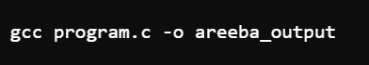

Then,run it with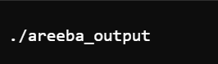

**Q2**: What is the purpose of the -o option in the gcc command? Provide an example.

**Solution**:  
The -o option in the gcc command specifies the name of the output file.



**Q3**: What is the difference between g++ and gcc? When would you use each?

**Solution**:

* gcc is used for compiling C programs, while g++ is for C++ programs.
* Use gcc for .c files and g++ for .cpp files.

**Q4**: How do you compile and run a C++ program from the terminal? Provide the necessary commands.

**Solution**:  
To compile a C++ program, use the g++ command followed by -o to specify the output filename. After compilation, run the program by prefixing the output filename with ./.



**Q5**: What are templates in C++ in Linux? Write a simple example of a function template.

**Solution**:  
Templates in C++ allow us to create flexible and reusable code that can handle any data type. This means you can write functions and classes that work with different types without having to rewrite them for each one.

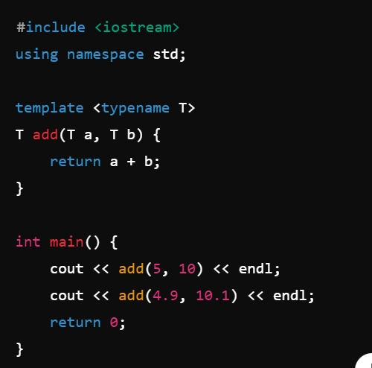

**Q6**: Discuss the significance of file extensions in C programming. Why should source files be saved with .c or .cpp extensions?

**Solution**:  
File extensions in C programming are important because they indicate the type of code contained within the file, allowing compilers and editors to recognize and process the files correctly.

* .c is for C programs.
* .cpp is for C++ programs.

**Q7**: What are the common errors that can occur when compiling C programs, and how can they be resolved?

**Solution**:

1. **Syntax Errors**: Mistakes in the code structure (e.g., missing semicolons).  
   **Resolution**: Check and correct the syntax according to C rules.
2. **Undefined Variables**: Using variables that haven’t been declared.  
   **Resolution**: Declare all variables before using them.
3. **Missing Header Files**: Not including necessary libraries.  
   **Resolution**: Add the appropriate #include statements at the top of the file.

**Q8**: Explain how you can manage permissions for an executable file in Linux. What command is used for this purpose?

**Solution**:  
In Linux, you can manage permissions for an executable file using the chmod command. This command allows you to change who can read, write, or execute the file.

**Q9**: What is a tarball, and what advantages does it offer for distributing software on Linux? Discuss the limitations of using tarballs for software installation and management.

**Solution**:  
A tarball is a compressed archive file created using the tar command. It combines multiple files and directories into a single file for easier distribution.

**Advantages**:

* Tarballs can hold all files needed for software in one package, making it easier to download and share.
* They reduce the file size, saving storage space and making downloads faster.

**Limitations**:

* It’s hard to keep track of the version or where the files are, making updates and removal tough.
* If the application needed other software, we had to install and update that manually.

**Q10**: Explain the purpose of the RPM package format and how it addresses the shortcomings of tarballs.

**Solution**:  
RPM, or Red Hat Package Manager, is a system used for installing software on Red Hat-based Linux distributions. It packages all the necessary components into a single file with a .rpm extension, including information about the software version, the list of included files, and any dependencies required for it to function. While the rpm command is used to install these packages, it can have difficulty managing dependencies, which may lead to issues if required software isn’t already installed.